|  |
| --- |
| *Optimal scheduling of minimizing estimation error and communication entropy of Markov sources* |

*2018-2nd Semester*

*Interdisciplinary Project*

|  |  |
| --- | --- |
| Student ID | 20141488 |
| Name | Jisu Lee |
| School | Electrical and Computer Engineering |
| 1 track | Computer Science and Engineering |
| 2 track | Electrical Engineering |
| Advisor 1 | Changhee Joo |
| Advisor 2 | Seungjoon Yang |

I. Introduction

1) Topic and Purpose of Research

In this work, we consider a network scenario where information sources (or senders) transmit their state to a remote estimator (or receiver). The remote estimator should keep tracking the time-varying state of source in a timely and accurate manner, while minimizing the use of limited wireless resources. This might be possible through optimized estimation and scheduling of remote estimator. The main question would be how the estimator evaluate sources in the networks.

There have been several research works to design estimation policies in various environments in the literature [1-4]. Wu et al. proposed an event-based sensor data scheduler corresponding minimum squared error estimator in one-sensor one-estimator environment [1]. Information age and communication time in a source and a receiver with channel queue is also considered [2][3]. Gao et al. discussed about minimizing expected distortion in the estimation of the state over a finite time horizon. But these works only considered single source and estimator [4]. In this work, we extend the results to multiple sources, which is non-trivial due to the constraint of network resources.

Traffic is also need to be considered, because using little traffic is a way to save communication fees. This can be expressed as Shannon entropy. It means the expected informal gain of a message [5].

In this study, we consider two Markov sources, and develop an algorithm that minimizes the cost of the information mismatch between the sources and the receiver, and the cost of information transmission between them. For a source, as time goes after an update, the uncertainty about the source state increases, which enlarges the information mismatch (i.e., the cost of error) as well as the amount of information for an update (i.e., the cost of transmission). In this work, we are focusing on finding an optimal solution to the update problem minimizing the total cost.

II. Main Subject

1) Research Planning

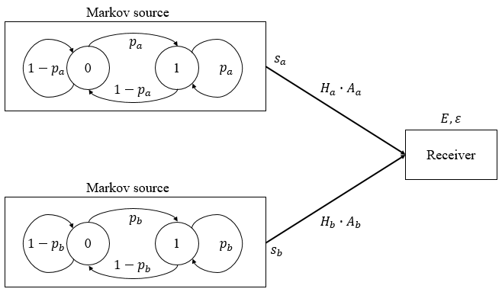 A. Problem Statement

Fig. 1. System model

To make problem simple, we considered two independent Markov sources with two states in discrete time. The transition matrix of each source is given by

$$P_{k}=\left[\begin{matrix}p_{k} & 1-p_{k} \\ 1-p_{k} & p_{k}\end{matrix}\right], where k ∈\left\{a, b\right\}.$$

Also, observing action is given by

$$A=\left[\begin{matrix}A_{a} \\ A_{b}\end{matrix}\right], where A ∈\left\{\left[\begin{matrix}1 \\ 0\end{matrix}\right], \left[\begin{matrix}0 \\ 1\end{matrix}\right], \left[\begin{matrix}0 \\ 0\end{matrix}\right]\right\}.$$

It means that receiver can take action of taking one source at each time or neither for observing. Then receiver observes the source whose $A_{k}$ is 1, and saves state $s_{k}$. The state of sources that are not observed changes stochastically. The $s_{k}$ is determined by last observed state of source k and ${\left(P_{k}\right)}^{{∆t}_{k}}$, ${∆t}_{k}$ is the passed time since the last observation.

Based on it, the receiver predicts the state of source k, which is

$$ε_{k}({∆t}_{k})= \underset{j}{argmax}{{{\left(P_{k}\right)}^{{∆t}_{k}}}_{s_{k},j}}$$

and the expected value of the case that the prediction is wrong is

$$E_{k}({∆t}_{k})=\begin{matrix}\min{{{\left(P_{k}\right)}^{{∆t}_{k}}}_{s_{k},j}} \\ 0\end{matrix} \begin{matrix}when A_{k}=0 \\ when A_{k}=1\end{matrix}$$

Also, when the receiver observes the source, information entropy occurs as

$$H_{k}\left({∆t}_{k}\right)=\begin{matrix}\sum_{i=s_{k}, j=\{0,1\}}{{{\left(P_{k}\right)}^{{∆t}_{k}}}_{i,j}∙\log_{2}{{{\left(P_{k}\right)}^{{∆t}_{k}}}_{i,j}}} \\ 0\end{matrix} \begin{matrix}when A_{k}=1 \\ when A_{k}=0\end{matrix}$$

Because each source has Markovian property, if time t = last observed time+ ${∆t}_{k}$,

$$E_{k}\left(t\right)=E_{k}\left({∆t}_{k}\right) and,$$

$$H_{k}\left(t\right)=H_{k}\left({∆t}_{k}\right)$$

We will suggests the algorithm that minimize

$$Cost=\sum_{t}{\sum_{k}{E_{k}\left(t\right)∙A_{k}\left(t\right)+ }βH_{k}\left(t\right)∙A_{k}\left(t\right)}$$

with some cost weight $β$.

B. Algorithm

a. Round robin

Round robin is the simplest way to update sources, it alternately updates sources in every time.

b. Cost minimization

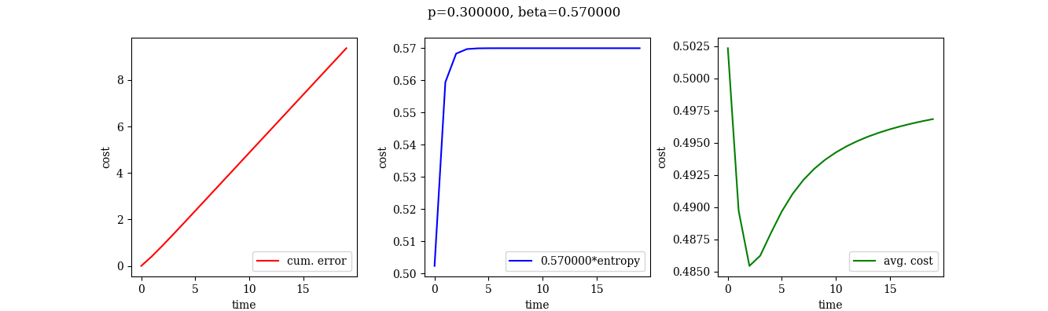After t=0, the observing cost of the source after time t is the sum of an accumulated prediction error up to t-1 before updating, and update entropy at time t. We calculated the average cost when updating at every time t, we got the result in Fig. 2. The variables are p = 0.3, $β$ = 0.57.

Fig. 2. Type of cost when receiver updates a source at time interval t

The avg. cost graph in Fig. 2 shows that there is an optimal update time that minimizes the average cost under certain conditions. So we calculate the optimal update time first for both sources. However, when executing update process, a conflict might occur in common multiple times of two optimal times. In this situation, the indicator is needed to decide what to update first. Receiver will update the source which has larger difference value of the optimal time and next time when conflict occurs. Thus, the receiver calculates the optimal update time and update priority for each source according to Algorithm 1.

|  |
| --- |
| Algorithm 1. Calculate optimal update time and priority of two sources |
| **Initialize**:  T = 0  Cost_min = 999 (as inf.) for each sources    **Repeat**:  T $←$ T+1  For each source:  Current_cost(T) = $\frac{\sum_{t=0}^{T}{\sum_{k}{E_{k}\left(t\right)∙A_{k}\left(t\right)+ }βH_{k}\left(t\right)∙A_{k}\left(t\right)}}{T+1}$ **If** Current_cost(T) $<$ Cost_min:  Cost_min $←$ Current_cost(T)  **Else**:  Diff = Current_cost(T) – Cost_min  **Return** T and Diff  **Until both sources return value** |

With this returned value, the receiver selects a source. All of this calculation is done by receiver.

III. Conclusion and Discussion

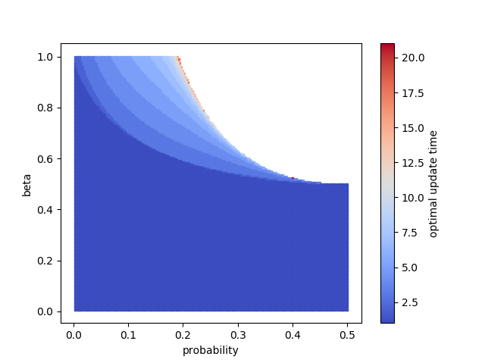1) Research Results

Fig. 3. Optimal update time of single source

Fig. 3 shows the optimal update time of one source which follows Algorithm 1. An empty space does not have value because the optimal update time goes to infinite. Also, the results with the probability range between (0.5, 1.0) are not shown because they are symmetric with respect to x = 0.5 in this graph.

In this way, we fixed the parameters $p_{a}$, and $β$ with 0.3, and 0.6 which makes optimal update time of source a 3, varied the values of $p_{b}$ from 0 to 0.5, and compared with the round robin and cost minimization algorithm policies.

The graphs (1) and (2) in Fig. 4 are cumulative values of E and H for each algorithm with each $p_{b}$ in 1000 times. (3) is the total cost and (4) is the update frequency of each source with cost minimization policy.

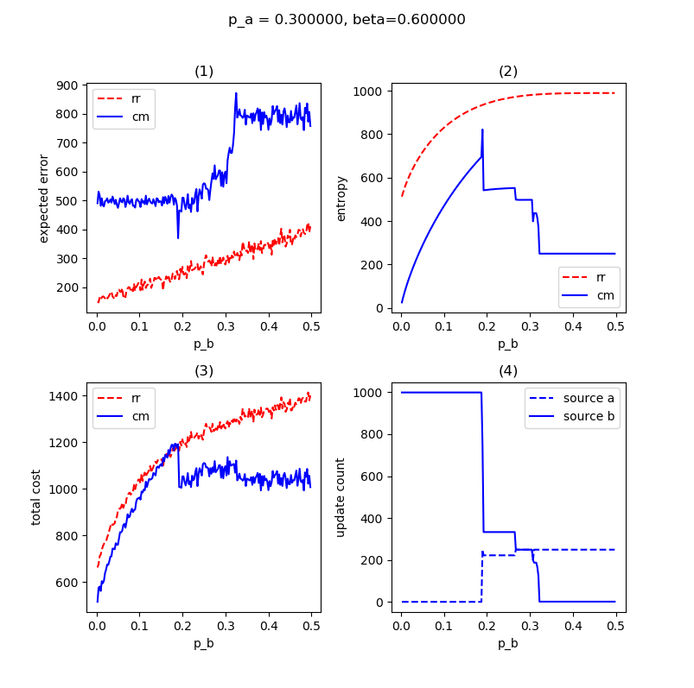

Fig. 4. Simulation Result

2) Discussion

As shown in the above experiment, suggested cost minimization algorithm can successfully reduce the cost compared to the round robin. However, as shown in Fig. 3 and 4, the $β$ value affects the probability range with a significant value. Therefore, when applying this algorithm, we needs to set an appropriate $β$ value with the relationship between sources. Also equation for $β$, probability, and optimal time will be more helpful in analyzing a multi Markov source system.

Since this method needs to know the characteristics of real sources and needs to calculate the optimal time in beforehand, it must recalculate if the probability of the Markov source changes. Therefore, this algorithm has a limit to apply to changing sources.

※ References

[1] Junfeng Wu, Qing-Shan Jia, Karl Henrik Johansson, Ling Shi, “Event-based sensor data scheduling: Trade-off between communication rate and estimation quality”, IEEE Transactions on automatic control, vol. 58, no. 4, pp. 1041-1046, Apr. 2013.

[2] Sanjit Kaul, Roy Yates, Marco Gruteser, “Real-time status: How often should one update?”, INFOCOM, pp. 2731-2735, Mar. 2012.

[3] Yin Sun, Elif Uysal-Biyikoglu, Roy D Yates, C Emre Koksal, Ness B Shroff, “Update or wait: How to keep your data fresh”, IEEE Transactions on Information Theory, vol. 63, no. 11, pp. 7492-7508, Nov. 2017.

[4] Xiaobin Gao, Emrah Akyol, Tamer Başar, “Optimal communication scheduling and remote estimation over an additive noise channel”, Automatica, vol. 88, pp. 57-69, Feb. 2018.

[5] Claude Elwood Shannon, "A mathematical theory of communication", Bell system technical journal, vol. 27, no. 3, pp. 379-423, Jul. 1948.